Accuracy of the data of my website with respect to that of Google.

**MY WEBSITE**

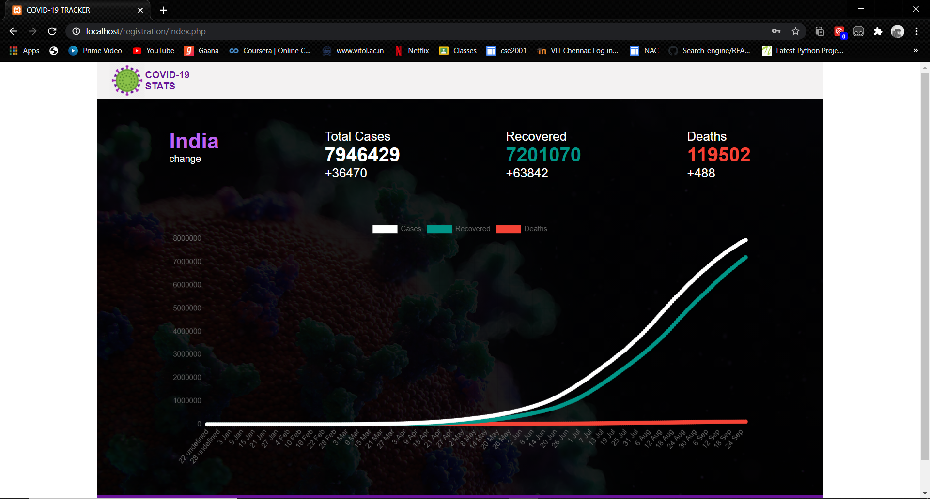

**IN GOOGLE**

